**Spike:** Spike No.17

**Title:** Task 17 – Sound Board

**Author:** Khang Trinh - 102118468

**Goals / Deliverables:**

The goal of this spike is to teach the developer how to learn their way through figuring out how to load, play and control game sound and music using their framework of choice.

**Technologies, Tools, and Resources used:**

* Visual Studio 2017

**Useful Links:**

1. Basic code for handling sounds and music using SDL2

<https://www.youtube.com/watch?v=0TlVpiQbFiE&ab_channel=CodingMadeEasy>

1. SDL_mixer official API

<https://www.libsdl.org/projects/SDL_mixer/docs/SDL_mixer.html#SEC38>

1. Basic guide on setting up SDL2 for your project

<https://www.youtube.com/watch?v=QQzAHcojEKg&ab_channel=Let%27sMakeGames>

**Tasks undertaken:**

## Step 0: Setting up the project

For each of the steps listed here, if you’re using a different framework than SDL, make sure to check their respective APIs to learn how to do this. If you’re using SDL2 and haven’t set up your project yet, follow link 1 and 3 to learn more about that.

## Step 1: Load files

Before being able to play any sounds, you need to first load them. *This usually happens before the loop.*



Fig 1. How music is loaded using SDL_mixer

## Step 2: Controlling sounds

There are a multitude of ways that you can go about controlling your soundtracks (play, stop, fade, volume, etc.). Check your framework’s API to learn how to make what you need.

Tip: When changing soundtracks, it’s usually worth checking whether there was already a track playing beforehand, so you can stop that track from playing first, then play your next one (if sound overlapping is not something you intended to have).

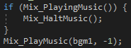 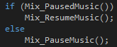

Fig 2. Some examples of sound handling using SDL

## Step 3: Clean up

Last, but most important, remember to always release the resources before quitting the application.

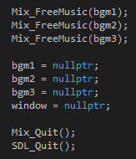

Fig 3. Releasing resources before quitting application